

# Belleville Dental

**Supervisor:** *NGUYỄN HẠ VY*

**Semester:** *01*

**Batch No:** *T3.2403.M1*

**Group No:** *05*

|  |  |  |
| --- | --- | --- |
| **Order:** | **Full name** | **Roll No.** |
| *1.* | *Dương Nguyên Chương* | Student1559417 |
| *2.* | *Lê Huy Hoàng* | Student1559416 |
| *3.* | *Nguyễn Huy Hoàng* | Student1518664 |
| *4.* | *Lê Nguyễn Kỳ Vĩ* | Student1559430 |

***Month****: 07* ***Year****: 2024*



This is to certify that

**Mr. DUONG NGUYEN CHUONG Mr. LE HUY HOANG Mr. NGUYEN HUY HOANG**

**Mr. LE NGUYEN KY VI**

Have successfully Designed & Developed

# BELLEVILLE DENTAL

Submitted by:

**Ms. DUONG NGUYEN CHUONG**

Date Of Issue:

29 – JULY - 2023

Authorized Signature:

**Mr. DUONG NGUYEN CHUONG**

**Content**

Content

Acknowledge

Synopsis

Problem Definition

Customer Requirements Specifications

Architecture and design of the project

1. Home pages
2. Service
3. About Us
4. Contact Us

**Acknowledge**

As we understand that the eProject is a step-by-step learning environment that closely simulates the classroom and Lab-based learning environment into actual implementation. It is a project implementation at your fingertips!! An electronic, live juncture on the machine that allows you to.

* Practice step by step i.e. laddered approach.
* Build a larger more robust application.
* Usage of certain utilities in applications designed by user.
* Single program to unified code leading to a complete application.
* Learn implementation of concepts in a phased manner.
* Enhance skills and add value.
* Work on real-life projects.

Give a real-life scenario and help to create applications that are more complicated and useful.

Mentoring through email support.

First of all, I would like to thank India Aptech for allowing my team to work on this fantastic eProject. We had a great experience with eProject this time.

Next, We would like to express my special thanks to our mentor, Ms. Ha Vy for the time and effort that she provided throughout the project. Your helpful advice and suggestions were beneficial to us during the completion of the project. In this respect, We are forever grateful to you.

Besides several mistakes we made in the project, we hope to have more opportunities to widen our knowledge in the web-developing world.

We will try to continue to learn and improve ourselves even more in the future.

Yours Sincerely, Team Group 05.

**Synopsis**

The Objective of this program we aim is to give a sample project to work on real- life projects. These applications help us build a larger more robust application.

The objective is not to teach us HTML/JavaScript but to provide us with a real-life scenario and help us create basic applications using the tools.

Hence, we can revise the chapters before we start with the project.

This project is meant for students like us who have completed the module of HTML5. These programs should be done in the Lab sessions with the assistance of the faculty if required.

The website (in this project) is a tool that brings everything in the world to you such as historic monuments information natural knowledge and skill in technology...

It is very essential for us that will have a clear understanding of the subject. We think we should go through the project and solve the assignments as per the requirements given.

And get back [***eprojects@aptech.ac.in***](mailto:eprojects@aptech.ac.in) as the assigned schedule.

**Problem Definition**

**Problem Statement**

Dental or oral health is concerned with your teeth, gums and mouth. The goal is to prevent complications such as tooth decay (cavities) and gum disease and to maintain the overall health of your mouth.

## ​​​​​​​​​​​​​​​​​​​​​​​​​​​​​​​​​​​​​​​​​​​​​​A healthy mouth, free of infections, injuries and other problems with teeth and gums, is important in maintaining your overall health.

Although a different set of medical professionals focuses on dental health, they are still part of your regular health care team.

Disease and other conditions can affect your dental health and dental problems can affect other parts of your body. Failing to properly care for your oral health may lead to other health problems.

You can help prevent or minimize many oral health problems by regular preventive steps (brushing, flossing and so on) and regular visits to dental health professionals.

Hence to increase the awareness and provide all information about dental care, we are looking for developing a website “Belleville Dental” based on the requirements mentioned below.

You are supposed to create a Single-Page-Application and responsive Website for them with the below mentioned requirement specifications.

The website should work well in all leading browsers including Chrome, IE, Firefox etc.

**Functional Requirement Specification:**

The portal will be designed as a Single-Page-Application and responsive Website with a set of pages and menus that represent choice of activities to be performed. The pages, menus, and other visual elements must be designed in a visually appealing manner with attractive fonts, colors, and animations.

All of these should also be laid out in a responsive manner

The Web site is to be created based on the following requirements.

1. The Top of the Page should be presented with a suitable logo and related images.
2. The site must contain the links to navigate through various options. Link titles mentioned below-
   * Professional education: This mainly includes the education assistance for students and practitioners. This can have further tabs/filters like finding related courses, help documents, faculty resources, student resources, case studies etc.
   * Patient education: This should include general and necessary information for the patients suffering from any of the oral/dental issues.
   * Research: This should include the latest research in the field. Necessary documents, videos etc. (media library) is expected here.
   * Products: As the name indicates it should include all the related products. Here filter should be available based on various types of products as tooth pastes , brushes, special products for kids, electrical accessories etc.
3. User should be allowed to enter rating for the products displayed in the website.
4. Site map, Gallery, about us, Queries link, Contact us link must be added.
5. About Us and Contact Us: This menu option should display Email id, address, and contact number of the organization who is developing the system.

Over and above this, the portal should implement the following functionalities:

* Display a continuous scrolling ticker at the bottom of the page with current date, time, and location (hint: Use geolocation features of HTML5).
* Display a visitor count at the top right corner of the page beside a logo image.
* The menu options should change color on hover and also after clicking.
* Fade in and fade out options can be used for the menus.

**Hardware/ Software Requirements**

**Hardware**

* Intel Core i3/i5 Processor or higher
* 8 GB RAM or above
* Color SVGA
* 500 GB Hard Disk space
* Mouse
* Keyboard

**Software**

Technologies to be used:

* Frontend: HTML5, CSS, Bootstrap, JavaScript, jQuery, React/AngularJS, Figma, XML
* Data Store: JSON files or TXT files

Other Requirements:

* Operating Portal: Windows
* Browsers: Edge, Chrome, Mozilla Firefox, Safari

**Project Deliverables**

You will design and build the project and submit it along with a complete project

report that includes:

• Problem Definition

• Design specifications

• Diagrams such as flowcharts for various activities, Data Flow Diagrams etc.

• Source Code

• Test Data Used in the Project

• Project Installation Instructions (if any)

Documentation is considered as a very important part of the project. Ensure that documentation is complete and comprehensive. The consolidated project will be submitted as a zip file with a ReadMe.doc file listing assumptions (if any) made.

**Submit a video clip demonstrating the working of the Website.** Optionally, a live hosted URL can be supplied for the site. Over and above the given specifications, you can apply your creativity and logic to improve the portal.

1. ***Home papes :***

1. ***About Us :***

***3.Contact :***

***4.Service :***

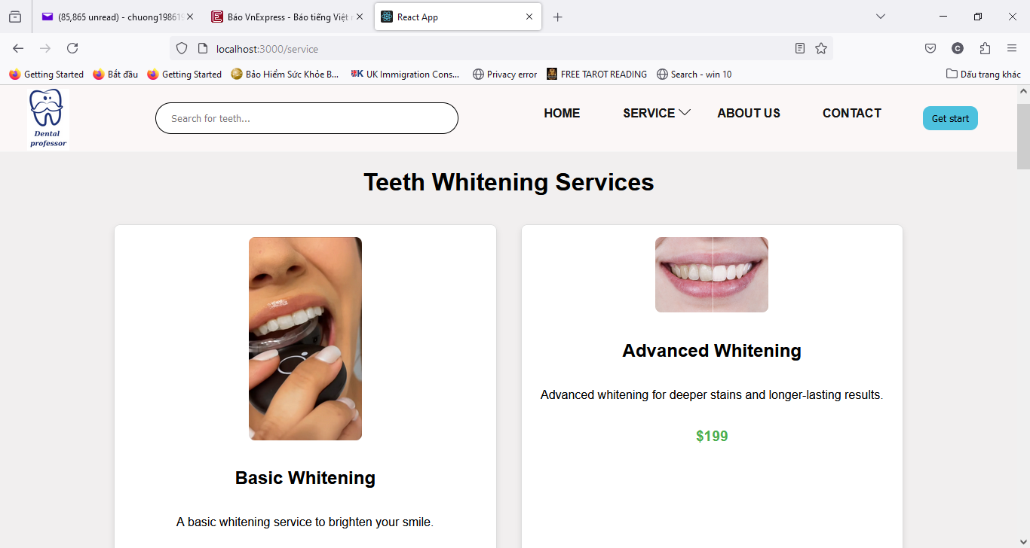

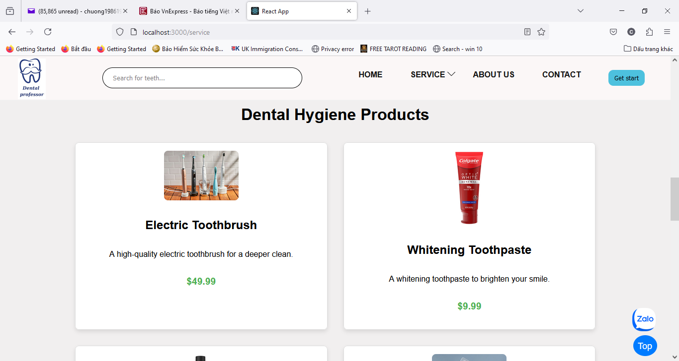

**Architecture and design of the project**

**Task Sheet**

|  |  |  |  |  |  |  |
| --- | --- | --- | --- | --- | --- | --- |
| **No** | **Member** | **Page Name** | **Planed Start Date** | **Actual Start Date** | **Actual End Date** | **Status** |
| *1.* | **DUONG NGUYEN CHUONG** | **Home** | 22/06/2024 | 07/11/2023 | 25/07/2024 | **100%** |
| **Service** | 22/06/2024 | 07/11/2023 | 26/07/2024 | **100%** |
| **About Us** | 22/06/2024 | 07/11/2023 | 25/07/2024 | **100%** |
| **Contact** | 22/06/2024 | 07/11/2023 | 25/07/2024 | **100%** |
|  |  |  |  |  |
| *2.* | **LE HUY HOANG** |  |  |  |  | **0%** |
|  |  |  |  | **0%** |
|  |  |  |  | **0%** |
|  |  |  |  | **0%** |
|  |  |  |  |  |
|  |  |  |  |  |
|  |  |  |  |  |
|  |  |  |  |  |
| *3.* | **NGUYEN HUY HOANG** |  | 22/11/2023 | 24/11/2023 |  | **0%** |
|  | 29/11/2023 | 29/11/2023 |  | **0%** |
|  | 06/12/2023 | 06/12/2023 |  | **0%** |
|  | 06/12/2023 | 06/12/2023 |  | **0%** |
| *4.* | **LE NGUYEN KI VI** |  | 22/11/2023 | 24/11/2023 |  | **0%** |